**User story: Create Seller Account**

Add user input to view options, add/create new account, delete account, update account username and email if already taken, check if all their details are correct and not already in use before performing add, delete and update functions, check if user input is the correct string type, exit program

**White box testing: Create Seller Account**

Test if account is created and test to check if account is added correctly

Test if account is updated and test to check if already in use details updated correctly

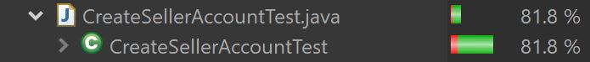

**User story: Manage Seller Password**

Add user input to view options, check if account exists, delete/undo password changes, update password by adding new password to the tempPassword csv file then updating the updatePassword csv file with new details when user confirms password change, check if user input is the correct string type, exit program,

**White box testing: Manage Seller Password**

Test if seller account already exists

Test to check if password is valid

Test to update password if valid input and check if password updated in csv file

Test to update password if invalid input and check if password is unaudited in csv file

Test to check If undo password change restores original csv file from temp csv file

**User story: Filter Properties**

Add user input to view filtering options of houses such as bed, bathroom and specific address, check if a house meets the specified criteria, delete all filters applied, undo/delete latest filter, view filtered houses, check if user choice input is a 1 letter string, exit program, after seeing the output user can update their choices to add more filters, remove some or remove all filters.

**White box testing: Filter Properties**

Test to check if all filters can be deleted successfully

Test to check if filtering by bathrooms shows output correctly

Test to check if adding filtering by beds shows output correctly

Test to check if adding filtering by a specific address (postcode) shows output correctly

Test to check if undo filters updated the properties showing in the filtered list

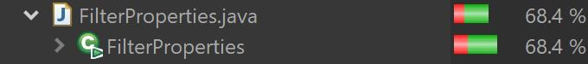

**User story: FAQ**

Add user input to search faq by topic, priority and helpfulness rating, check if user choice input is a 1 letter string, view filtered faq, view faq without filter, delete all filters applied, undo/delete latest filter applied, exit program, after seeing the output user can update their choices to add more filters, remove some or remove all filters.

**White box testing: FAQ**

Test to check if FAQ details are printed correctly

Test to check is if adding filtering by topic is showing the output correctly

Test to check is if adding filtering by priority is showing the output correctly

Test to check is if adding filtering by helpfulness is showing the output correctly

Test to check if all filters can be deleted successfully

Test to check if undo filters updated the properties showing in the filtered list

Test to check if updating filters are showing output correctly by applying more than 1 filter

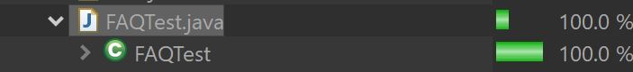

**User story: Submit Help Form**

Allow user to add a new form, delete form, update form and check if all form details are correct before submitting to admin to original csv from temp csv, and exit menu.

**White box testing: Submit Help Form**

Test to check if forms can be viewed after submission through unique Request ID

Test to check if forms can be updated after submission through unique Request ID

Test to check if new forms can be added and submitted

Test to check if forms can be deleted through unique Request ID

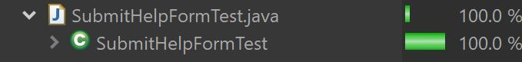

**User story: View Help Form**

Allow admin to add comment to a form, delete form, update form status and check if all form details are correct before submitting to original csv from temp csv, and exit menu.

**White box testing: View Help Form**

Test to check if admin can view submitted help forms

Test to check if admin can update help form status

Test to check if admin can delete help forms is solved or considered inappropriate



